Schema Creation Steps

|  |  |  |  |
| --- | --- | --- | --- |
| 更新历史 | | | |
| 版本 | 修订人 | 日期 | 修订描述 |
| V1.0 | LiuGuohua | 2019-01-22 | 初始版本 |
| V1.1 | Wudun | 2019-01-23 | 更新 |
| V1.2 | LiuGuohua | 2019-01-23 | 更新验证sql |
| V1.2 | LiuGuohua | 2019-03-22 | Add comment for DB update |
|  |  |  |  |
|  |  |  |  |

## CREATE TABLESPACE

CREATE TABLESPACE "TBS_TEST" DATAFILE '/home/oracle/app/oracle/oradata/test/TEST001.DBF'

SIZE 500M

AUTOEXTEND ON

NEXT 10M

MAXSIZE 32767M;

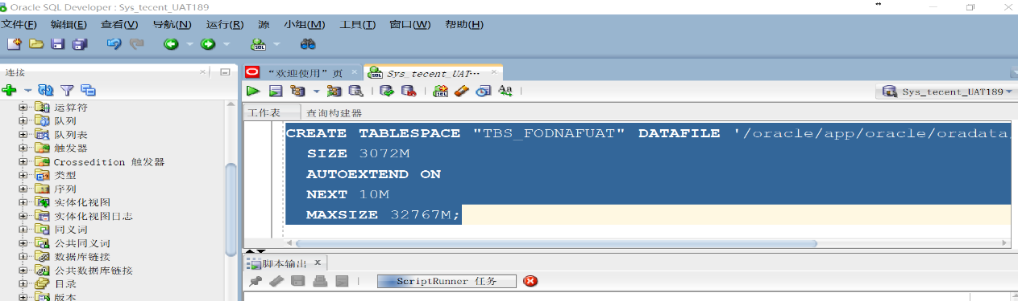

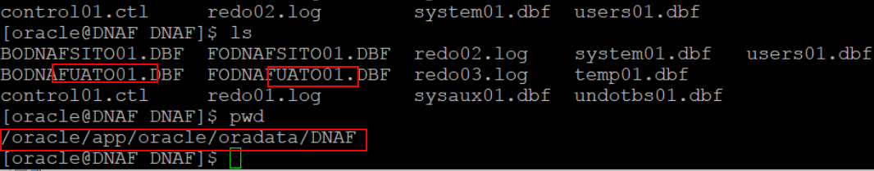

## CREATE USER

CREATE USER "TEST" IDENTIFIED BY TEST

DEFAULT TABLESPACE "TBS_TEST"

TEMPORARY TABLESPACE "TEMP";

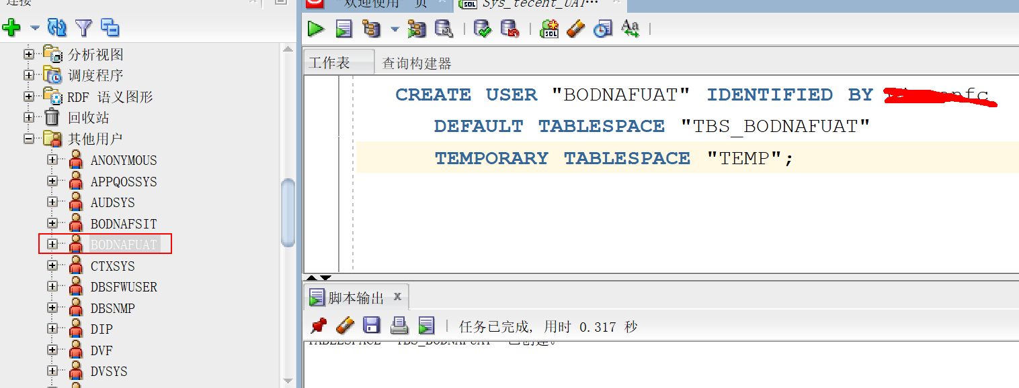

## Grant user and import dump file

grant create session, resource to TEST;

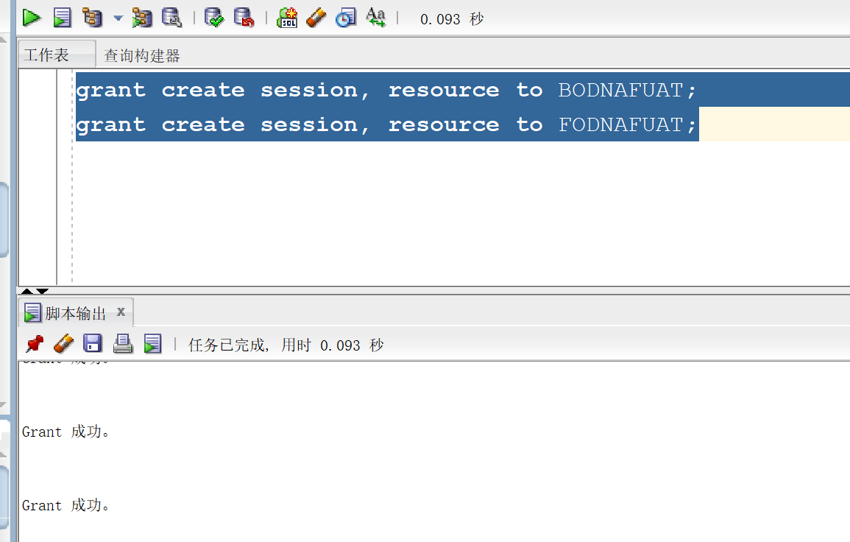

1. **Create new connection on SQLDEVELOPER for user(FODNAFUAT3/BODNAFUAT3)**

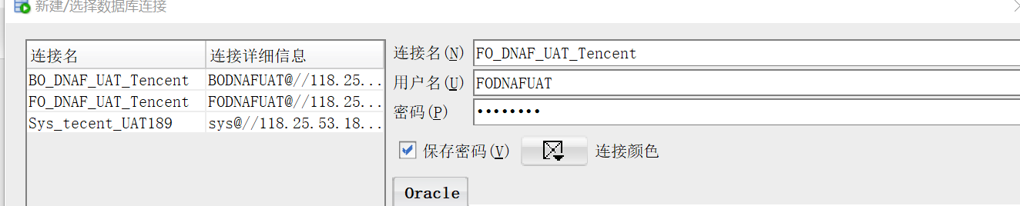

1. **Import dump file from Dev env(SIT locate in 189)to UAT2**

**Data location as below**

Run below command in putty with oracle user:

impdp dumpfile=test.dmp logfile=test20200107.log

impdp dumpfile=test.dmp directory=DATA_PUMP_DIR logfile=test.log transform=OID:n SCHEMAS=TEST REMAP_SCHEMA=TEST:DNAF EXCLUDE=GRANT REMAP_TABLESPACE=TBS_TEST:TBS_TEST